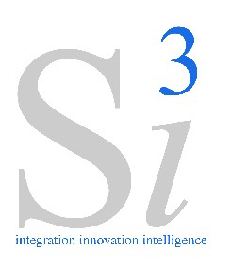 |  | 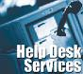
Si3 - IT Help Desk Support
Services
About Si3
Si3 is one of Pakistan's Premier IT Systems Integrator with capacity and experience for providing strategic technology solutions that achieve real business results for businesses in diverse industries including Financial Services, Logistics, Telecommunications, Oil & Gas, Defense, and the Public Sector. Si3 professionals along with alliance partners provide an unmatched level of domain expertise with a results-oriented approach. The Company delivers business value using IT to empower organizations with innovative and scalable technology solutions that increase their competitive advantage and return on investment.

What This Services All About  If you are in a business which uses IT equipment and seeking guaranteed solution for your Help Desk Service and Technical Support needs, our help desk service can give you that and more.  Si3 help desk services will give you the freedom to focus on your core competencies while giving your employees or customers a pleasant, satisfying help desk experience.  Our IT support call center handles everything from operating systems, customized desktop applications to troubleshooting complex computer software and hardware problems. |  | Benefits of Si3 IT Help Desk  We work with each of our clients to design a specific Service Level Agreement (SLA) to meet their particular support requirements backed by 24x7 help desk support which is reviewed and randomly monitored by Si3 management to ensure compliance with SLAs and search for ways to improve our help desk services. Si3 provides a means to:  - Lower your technical support costs.  - Reduce your management headaches.  - Give your employees a professional IT support experience.  - Improve your overall computer utilization.  - Reduce your IT related capital budget. |  | 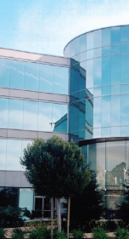
IT Help Desk Service Offerings  Si3 can supply your  organization L3 support with the onshore resources needed to provide quality and cost-effective support when any complain could not be resolved by Level 1 or Level 2 support .    We offer a complete line of Level 1 and Level 2 support through:  - Telephone  - E-mail  - Live Internet Text Chat  - Remote Desktop  Provisioning of  Resident Engineer  Si3 also provide contractual based services of resident engineer for smooth IT operation of your organization during the normal business hours with an advantage of telephonic IT help desk support after normal business hours around the clock. |  | What Our Help Desk Provides  Si3's experienced help desk support engineers are available to resolve your IT operations related issues around the clock with the following options.  Option 1:  In this option we provide our help desk services from 9 AM to 6 PM and it covers following Support Services:  - Computer hardware Troubleshooting.  - Software Support.  - Network Troubleshooting.  Option 2:  In this option we provide our Help Desk Services on 24X7X365 and it covers following Support Services:  - Computer hardware Troubleshooting.  - Software Support.  - Network Troubleshooting. |  |  | 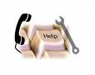  For more information on this services, please contact:  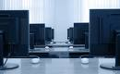  System Innovations (Pvt) Ltd.  First Floor, State Life Building  No. 1B, I.I. Chundrigar Road , Karachi 74000,  Pakistan  UAN: 111 111 743  Fax: 021 2425357  Email: info@s-iii.com  URL: www.s-iii.com

